1.What are the two values of the Boolean data type? How do you write them?

**Ans.** True and False is boolean data type . and you can write as True and False

2. What are the three different types of Boolean operators?

**Ans.**  AND, OR, NOT is a boolean operators

3. Make a list of each Boolean operator's truth tables (i.e. every possible combination of Boolean values for the operator and what it evaluates ).

4. What are the values of the following expressions?

(5 > 4) and (3 == 5)

**False**

not (5 > 4)

**False**

(5 > 4) or (3 == 5)

**True**

not ((5 > 4) or (3 == 5))

**False**

(True and True) and (True == False)

**False**

(not False) or (not True)

**True**

5. What are the six comparison operators?

**== -> Equal**

**!= -> Not equal**

**> -> Greater than**

**< -> Less than**

**>= -> Greater than or equal to**

**<= -> Less than or equal to**

6. How do you tell the difference between the equal to and assignment operators?Describe a condition and when you would use one.

**Answer: -** Equal to operator is used to store the value in variable and assignment operators is used to compare the values

7. Identify the three blocks in this code:

spam = 0

if spam == 10:

print('eggs')

if spam > 5:

print('bacon')

else:

print('ham')

print('spam')

print('spam')

**Output:-**

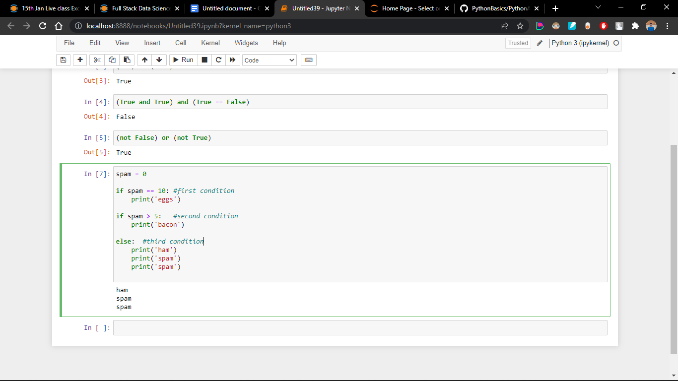

8. Write code that prints Hello if 1 is stored in spam, prints Howdy if 2 is stored in spam, and prints Greetings! if anything else is stored in spam.

**Output:-**

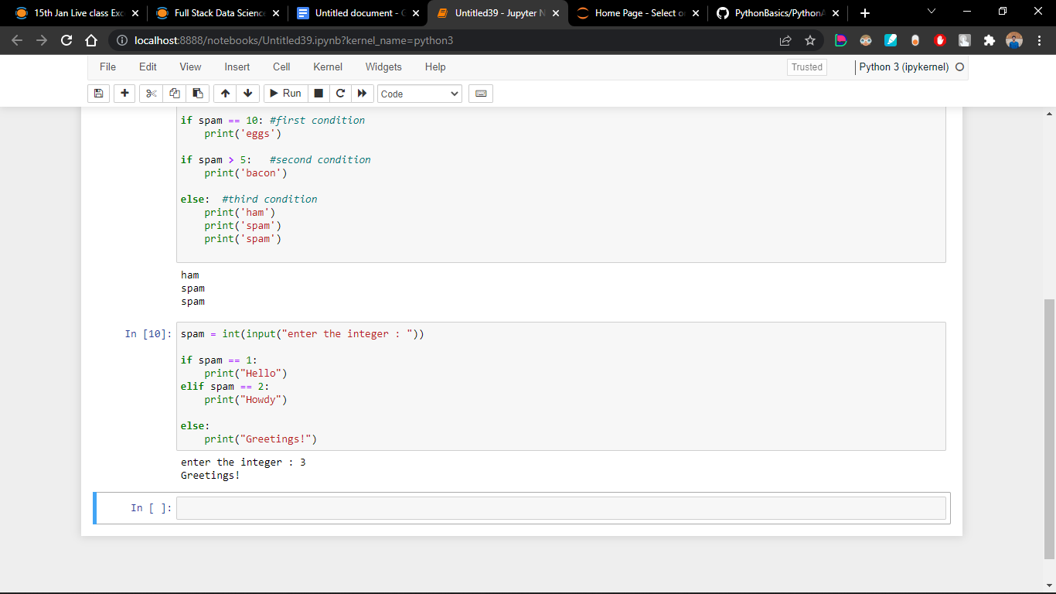

9.If your program is stuck in an endless loop, what keys will you press?

Answer:- CTRL + c keys used to stop the endless loop

10. How can you tell the difference between break and continue?

**break** function eliminates the execution of the iteration of the remaining loop .

**continue** function terminates the current iteration of the loop.

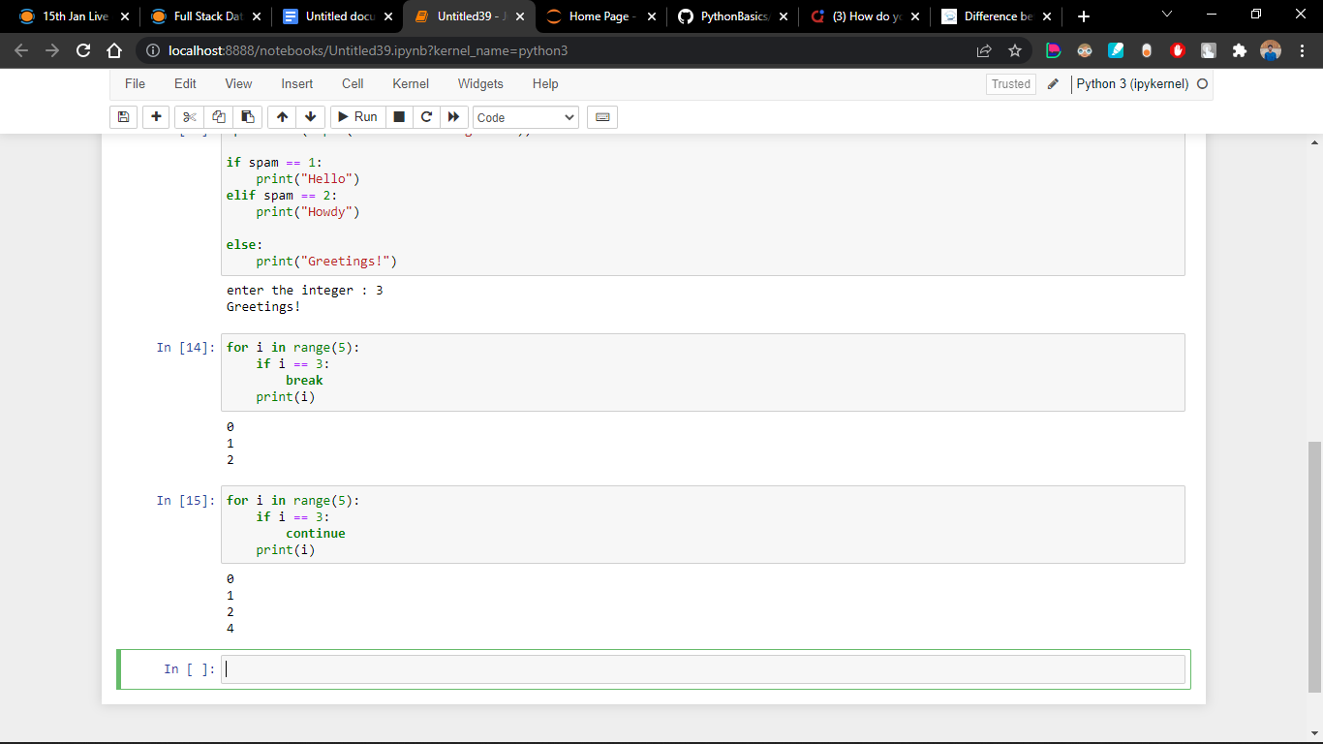

11. In a for loop, what is the difference between range(10), range(0, 10), and range(0, 10, 1)?

Technically there is no difference between range(10), range(0,10),range(0,10,1)

Because every range initial integer is 0 and default step is always 1

**Output:-**

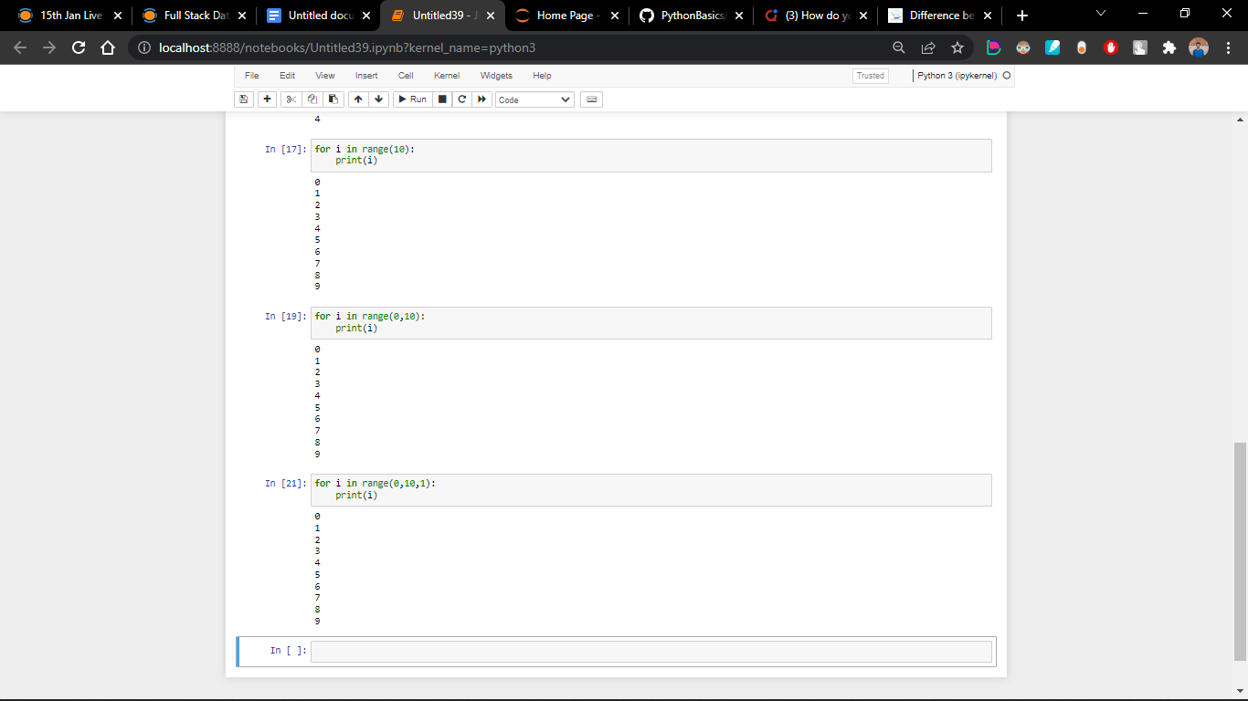

12. Write a short program that prints the numbers 1 to 10 using a for loop. Then write an equivalent program that prints the numbers 1 to 10 using a while loop.

**Output:-**

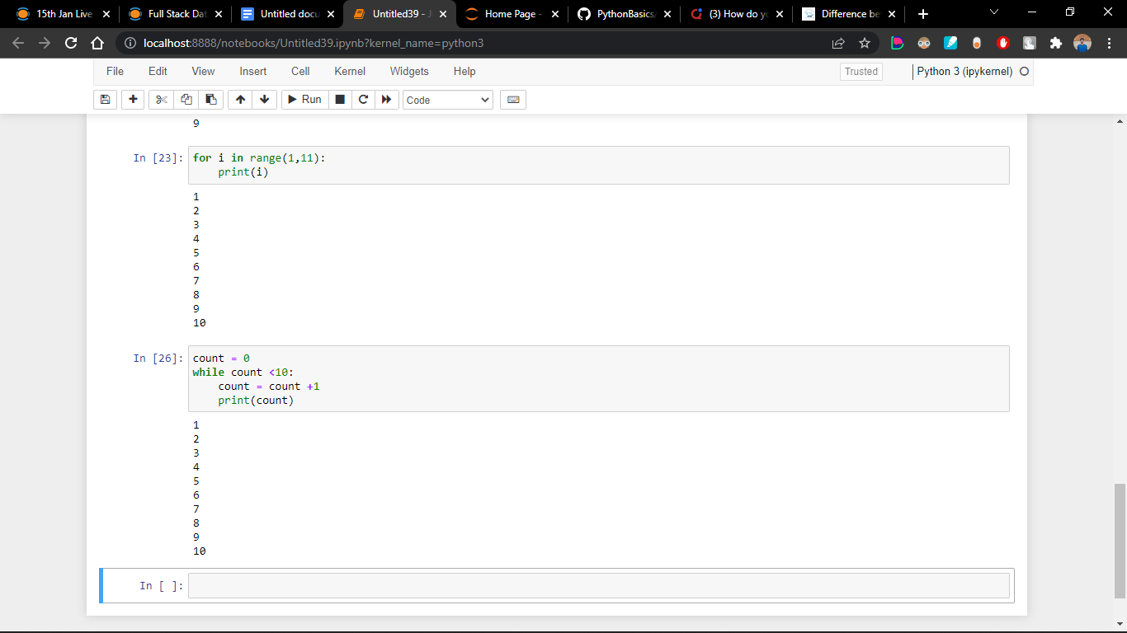

13. If you had a function named bacon() inside a module named spam, how would you call it after importing spam?

**Import spam**

**After_importing = spam.bacon()**